Job descriptions: Style guide for venues / employers
LTA Coaching Jobs page

Thank you for choosing to advertise your vacancy on the LTA website. Advertising on the LTA coaching jobs page is a great way to connect with coaches. So that we can advertise your unique role in a consistent way to the coaching workforce, below you will need to confirm a number of details about the position. To ensure your roles are uploaded swiftly, please ensure that you complete all fields, and follow the guidance. There are 14 sections below, whereby you have the chance to confirm all the relevant details for the job.

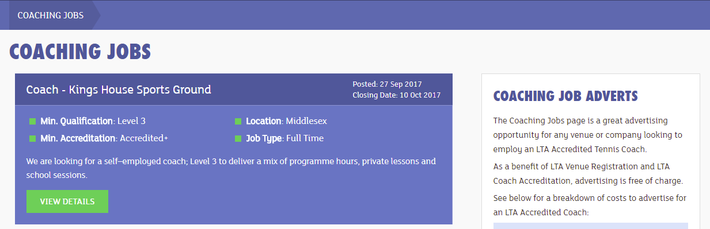

Image 1: An example of a Coaching Jobs summary listing on the LTA website.

- Job Title
Guidance notes: The title that displays on the LTA Coaching jobs page (shown in the dark blue strip above) will include just two pieces of information – specifically the ‘role’ and the ‘venue/company’ associated with that role. E.g. Assistant Coach – Clevedon Lawn Tennis Club. Please underline below which role, then specify explicitly which venue/organisation is associated with that role. If there are multiple venues, underline “Multiple venues”.

- Role:

Assistant Coach (Level 1 or 2 Coach)
Coach (Level 3 or above Coach)
Head Coach (Level 3 or above, but typically a Level 4 or 5 Coach)
Administrative Role (Non-coaching role)
Sports Manager (Non-coaching role)
General Assistant (Non-coaching role)
Centre Assistant (Non-coaching role)
Racquets Manager (Non-coaching role)
University Tennis Coordinator (Non-coaching role)
Other [please specify]

- Venue:

[Insert venue / company name here] OR
Multiple venues

- One line summary
Guidance notes: Use this short sentence to catch people’s attention when browsing roles on the page. Do not repeat here what is included in the Job title. This line cannot exceed 160 characters, including spaces, so it needs to be brief and to the point. This line should emphasise the personal attributes required for the role in question e.g. “We are looking for a passionate individual for an exciting position at a leading venue in the South-West” or “A committed head coach is needed to drive a large performance programme”. Other attributes could include; Positive, Patient, Cooperative, Caring, Enthusiastic, Inclusive, Encouraging etc.

[Insert one line summary here]

- Employer
Guidance notes: Enter here the name of the entity that will be deploying the coach. In many cases, this will be the venue i.e. the same as what you entered in 1b

[Insert employer’s name here]

- Minimum Qualification
Guidance notes: Level 1 and 2 qualifications are assistant coach qualifications. Therefore, if your minimum requirement is a Level 1 or Level 2, then the job title (Question 1a above) will align accordingly when published and be stated as an ‘Assistant coach’. If your minimum requirement is a Level 3 or above, then your job title can be either ‘Coach’, or ‘Head Coach’ (Head coach only applies when the role involves managing a team of coaches). Please ensure your responses to 1a and 4 are aligned, otherwise this will delay the publication of your advert. Please underline one of the options below. More info on LTA Coach Qualifications can be found here

Level 1 or above (if you choose this, the job title will be published as “Assistant Coach”)
Level 2 or above (if you choose this, the job title will be published as “Assistant Coach”)
Level 3 or above
Level 4 or above
Level 5 or above
NA (for non-coaching roles)

- Minimum Accreditation
Guidance notes: Coach Accreditation is LTA’s professional membership scheme for tennis coaches. It offers deployers the security that a coach is qualified and meets best practise guidelines. An LTA Accredited Coach holds a valid qualification (level 1-5), is first aid trained, and can demonstrate that they are safe to practice through appropriate CRC checks. Accredited coaches are not required to complete professional development. An LTA Accredited+ Coach holds a level 3-5 qualification, is first aid trained and can also demonstrate that they are safe to practice through appropriate CRC checks. Accredited+ also guarantees that the coach will have completed 15 hours of professional development each year. Please underline one of the options below.
More info on Coach Accreditation can be found here.

Accredited
Accredited+
Contact employer (for international roles only)
NA (for a Non-coaching role)

- Closing Date
Guidance notes: It is recommended that you provide a 2 to 6 week lead time for advertising a role, from the day it is published. Only in exceptional circumstances should the closing date be less than two weeks, or more than six weeks.

[DD/MM/YY]

- Salary Type
Guidance notes: Please underline one of the options below.

Annual
Daily
Hourly
Volunteer (unpaid)
Contact Employer

- Salary / Daily or Hourly rate
Guidance notes: Currently the LTA do not give prescriptive guidance on coach salaries nor hourly rates, primarily due to the number of variables that impact pay including geographical location, years’ experience of the coach, level of qualification of the coach, venue type and the fact that it is primarily a self-employed profession. Due to the variance across all these factors it is difficult to give meaningful benchmarks or guidance. It is therefore up to the deployer of the coach to specify the amount of pay e.g. £30, £25,000, £20,000 - £25,000. The amount must be shown in GBP, for International roles please convert to GBP.

[Enter quantity here]

- Job Type
Guidance notes: For the purposes of publishing consistent adverts that coaches can find or compare quickly, the LTA define a part-time coaching role as 21 hours or below, whilst a full-time role is defined as 21 hours or above. Please underline one of the options below.

Part time
Full time

- Location (please state below as applicable)
Guidance notes: If your role is in England, you can specify which county it is in. Otherwise, please state ‘Scotland’, ‘Wales’. If the role is not in the UK, please state “International”.

[Enter location here]

- Job description
Guidance notes: Describe the job itself here. Do not include a description of your venue/company as this comes later. A high quality description will include the following; Purpose of the role, Key responsibilities, is the role part of a team or a solo coach role? Include any other details you feel describe the job well.

[Insert your job description here]

- Overview of the venue/company
Guidance notes: Describe the venue (or company if more applicable) itself. Do not include a description of the job here. A high quality description will include; Mission statement of the venue / company, details of where the venue / company is based, size of venue / company (how many courts, indoor / outdoor), mention the programmes delivered, membership details (if applicable), existing local links e.g. to schools etc.

[Insert your venue/company description here]

- Person specification
Guidance notes: This is your opportunity to describe the type of competencies and attributes you think will make an ideal candidate. This can include the years of experience required / preferable, the competencies that are required to do the job to a high standard (technical, organisational, communicative, business skills etc.). Examples of attributes could include; Passionate, Enthusiastic, Inclusive, Supportive, Dedicated, Positive, Patient, Caring. E.g. “The ideal candidate for this role will be a passionate assistant coach with great communication skills and a minimum of two years’ experience”.

[Insert your person specification description here]

- How to apply
Guidance notes: Here you will need to include what to attach in an application, as well as the contact email address and/or phone number. If you have a start date established, please include that in DD/MM/YY format. We recommend you request both a CV and a cover letter. E.g. “Applications should include a one page cover letter and CV, which can be sent to…”

[Enter how to apply details here]

