Tennis Club Constitution Template
A template of a Constitution that can be adapted to suit the needs of your tennis club. Please take time to read the accompanying Constitution Guidance resource and edit this template to include details relevant to your tennis club.
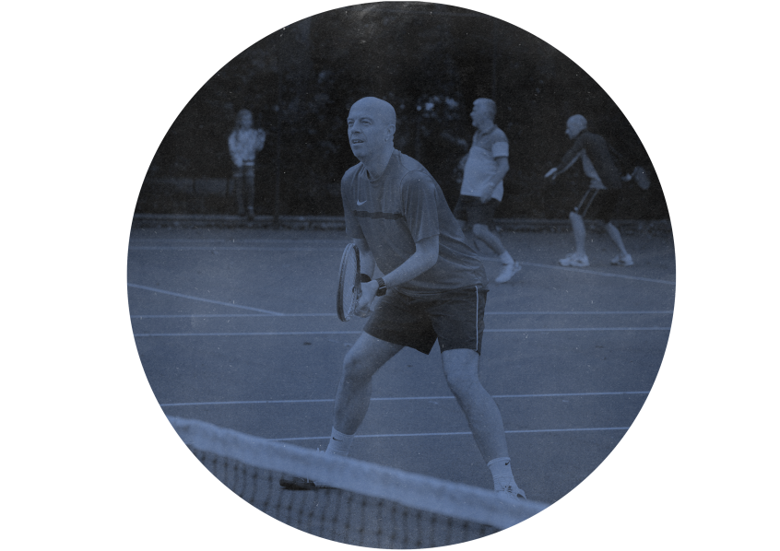

Club Constitution Template
Last updated: July 2017

Tennis Club Constitution Template

- Name of Club

The club will be called NAME OF CLUB (Hereinafter will be referred to as The Club), and may also be known as ABBREVIATION OF NAME. NAME OF CLUB will be registered and affiliated to the Lawn Tennis Association.

2 Aims and Objectives

The aims and objectives of the club will be:
- To offer tennis coaching and competitive opportunities.
- To promote the club and tennis participation within the local community
- To manage the NAME OF FACILITY
- To ensure a duty of care to all members of the club
- To provide all services in a way that is fair to everyone

3 Membership

(a) Membership of the club is open to anyone interested in coaching, volunteering or participating in tennis, regardless of sex, age, disability, ethnicity, nationality, sexual orientation, religion or other beliefs.

(b) The membership shall consist of the following categories:
- Full member
- Junior member AMEND TO SUIT YOUR CLUB
- Student member AMEND TO SUIT YOUR CLUB
- AMEND TO SUIT YOUR CLUB

(c) All members will be subject to the regulations of the constitution and by joining the club will be deemed to accept these regulations and codes of practice that the club has adopted.

(d) Members in each category will pay membership fees. The costs and timeframes for paying these fees will be determined at the Annual General Meeting.

(e) Individuals shall not be eligible to take part in the business of the Club, vote at general meetings or be eligible for selection of any Club team unless the applicable subscription has been paid by the due date and/or membership has been agreed by the Club committee.

- Equal Opportunities
- This Club is committed to ensuring that equity and equal opportunities is incorporated across all aspects of its development.

- The Club respects the rights, dignity and worth of every person and will treat everyone equally within the context of tennis, regardless of age, ability, gender, race, ethnicity, religious belief, sexuality or social/economic status.

- The Club is committed to everyone having the right to enjoy their sport in an environment free from threat of intimidation, harassment and abuse.

- All club members have a responsibility to oppose discriminatory behaviour and promote equality of opportunity.

- The Club will deal with any incidence of discriminatory behaviour seriously, according to club disciplinary procedures.

- Committee

- The affairs of the Club shall be conducted by a Committee which shall consist of the Chair, Treasurer, and Secretary [PLUS ANY OTHER POSITIONS YOUR CLUB WISHES TO INCLUDE], who shall be elected at the Annual General Meeting.

- All committee members must be members of the Club.

- If required, the committee shall elect a Vice Chair from among its members.

- The term of office shall be for one year, and members shall be eligible for re-election.

- If the post of any officer or ordinary committee member should fall vacant after such an election, the Executive Committee shall have the power to fill the vacancy until the succeeding Annual General Meeting.

- The Committee will be responsible for adopting new policy, codes of practice and rules that affect the organisation of the club.

- The Committee will have powers to appoint any advisers to the Committee as necessary to fulfil its business.

- The Committee will be responsible for disciplinary hearings of members who infringe the club rules/regulations/constitution. The Committee will be responsible for taking any action of suspension or discipline following such hearings.

- The committee meetings will be convened by the Secretary of the Club and be held no less than NUMBER OF MEETINGS [4-6 AS A GUIDE] times per year.

- Only the posts listed above will have the right to vote at committee meetings.

- The quorum required for business to be agreed at Management Committee meetings will be NUMBER [ACCORDING TO NUMBER OF OFFICERS IN POST, 40% AS A GUIDE].

- Finances

(a) The club treasurer will be responsible for the finances of the club.

(b) The financial year of the club will run from DATE and end on DATE

(c) All club monies will be banked in an account held in the name of the club.

(d)An audited statement of annual accounts will be presented by the treasurer at the Annual General Meeting.

(e) Any cheques drawn against club funds should hold the signatures of the treasurer plus up to two other officers.

- All members of the Club shall be jointly and severally responsible for the financial liabilities of the Club.

- All surplus income or profits are to be reinvested in the club. No surpluses or assets will be distributed to members or third parties.

- Annual General Meetings and Extraordinary General Meetings

- General Meetings are the means whereby the members of the Club exercise their democratic rights in conducting the Club’s affairs.

- The Club shall hold the Annual General Meeting (AGM) in the month of MONTH to:
- Approve the minutes of the previous year’s AGM.
- Receive reports from the Chairman and Secretary.
- Receive a report from the Treasurer and approve the Annual Accounts.
- Receive a report from those responsible for certifying the Club’s accounts.
- Elect the officers on the committee.
- Agree the membership fees for the following year.
- Consider any proposed changes to the Constitution.
- Deal with other relevant business.

- Notice of the AGM will be given by the club secretary with at least NUMBER [USUALLY BETWEEN 14-28] days’ notice to be given to all members.

- Nominations for officers of the committee will be sent to the secretary prior to the AGM.

- Proposed changes to the constitution shall be sent to the secretary prior to the AGM, who shall circulate them at least 7 days before an AGM.

- All members have the right to vote at the AGM.

- The quorum for AGMs will be NUMBER [USUALLY 10% OF THE MEMBERSHIP].

- The Chairman of the Club shall hold a deliberative as well as a casting vote at general and committee meetings.

- An Extraordinary General Meeting (EGM) shall be called by an application in writing to the Secretary supported by at least 10% of the members of the Club. The committee shall also have the power to call an EGM by decision of a simple majority of the committee members.

- All procedures shall follow those outlined above for AGMs.

- Amendments to the constitution

The constitution will only be changed through agreement by majority vote at an AGM or EGM.

- Discipline and appeals

- All concerns, allegations or reports of poor practice/abuse relating to the welfare of children and young people will be recorded and responded to swiftly and appropriately in accordance with the club’s child protection policy and procedures. The Club Welfare Officer is the lead contact for all members in the event of any child protection concerns.

- All complaints regarding the behaviour of members should be presented and submitted in writing to the Secretary.

- The Management Committee will meet to hear complaints within NUMBER days of a complaint being lodged. The committee has the power to take appropriate disciplinary action including the termination of membership.

- The outcome of a disciplinary hearing should be notified in writing to the person who lodged the complaint and the member against whom the complaint was made within NUMBER days of the hearing.

- There will be the right of appeal to the Management Committee following disciplinary action being announced. The committee should consider the appeal within NUMBER days of the Secretary receiving the appeal.

- Dissolution

(a) A resolution to dissolve the club can only be passed at an AGM or EGM through a majority vote of the membership.

(b) In the event of dissolution, all debts should be cleared with any clubs funds. Any assets of the club that remain following this will become the property of ANOTHER CLUB WITH SIMILAR OBJECTIVES or THE NAME OF GOVERNING BODY

- Declaration

NAME OF CLUB hereby adopts and accepts this constitution as a current operating guide regulating the actions of members.

Name |  | Position | Chair
Sign |  | Date

Name |  | Position
Sign |  | Date

